AI Trends Lab Evaluation

Q1 .PERFORM USING THE SCREEN SHOT OF YOUR ACCOUNT LOGIN

Create a local git repository

Commit the initial code

Update the code on the remote server. Also perform some changes on remote n

reflect the same on local.

Use git commands to

to create branches in git

diff between branches

logs of the commit

Revert of changes

A1.

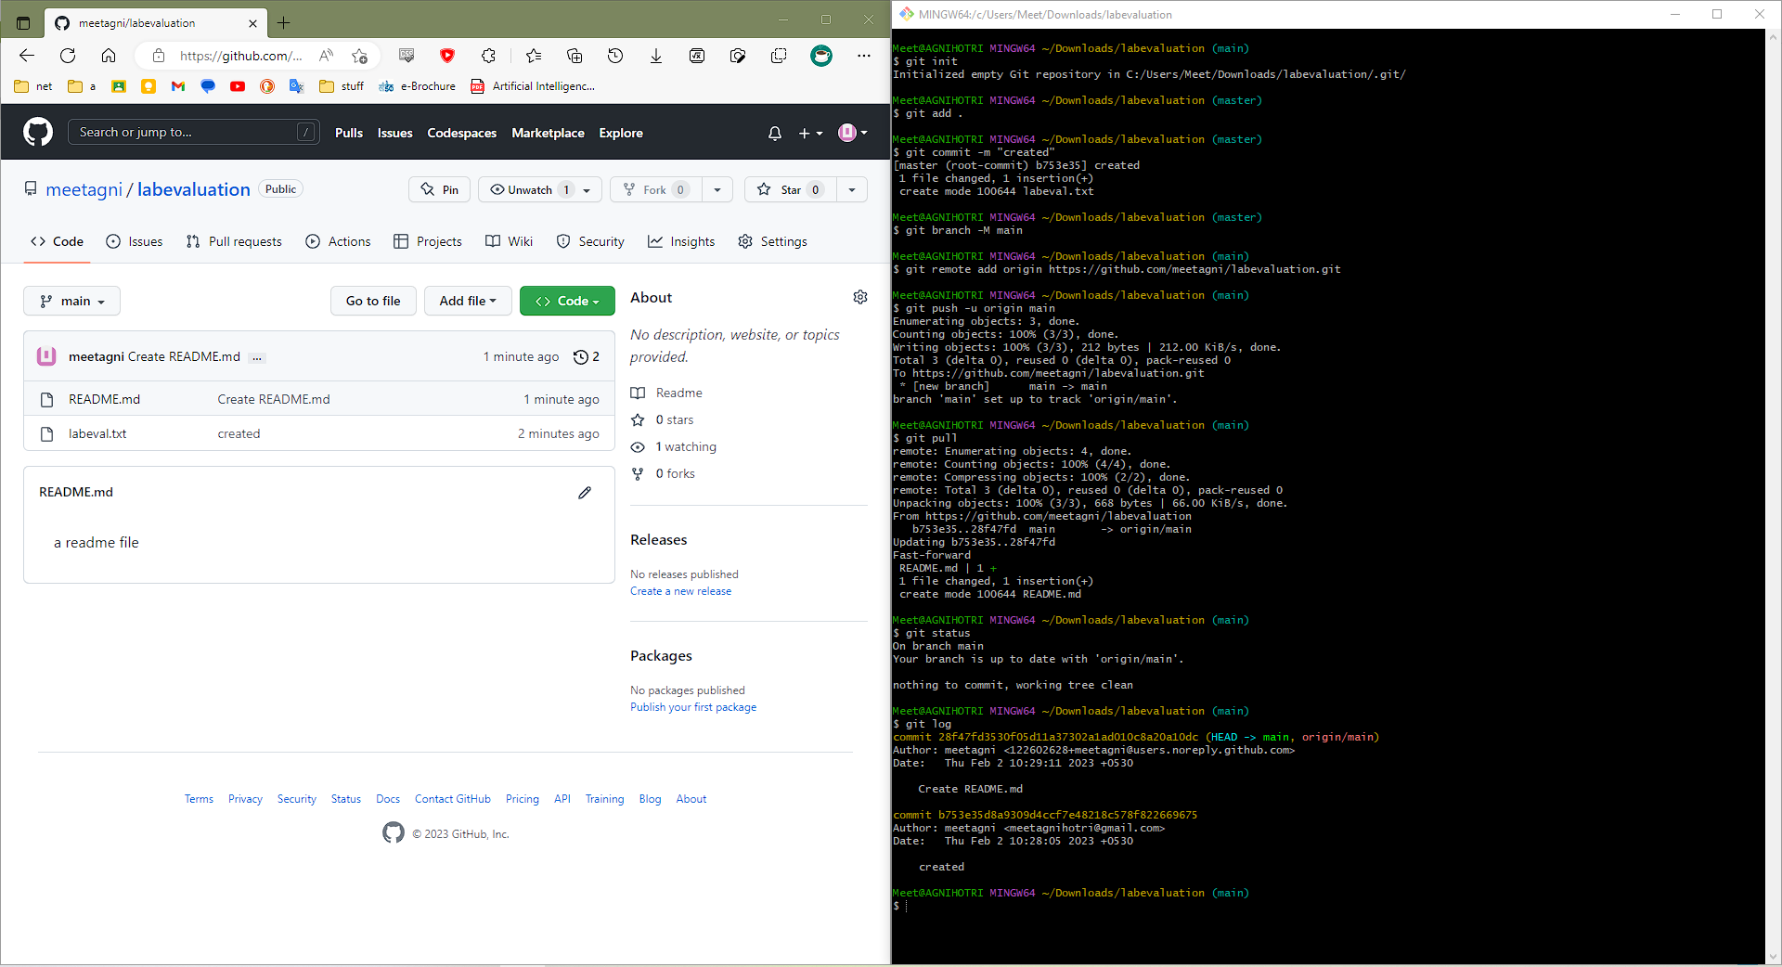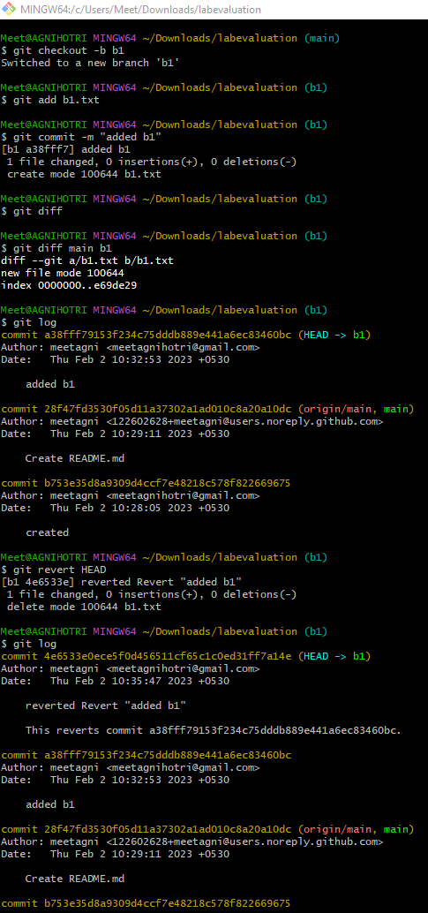

Q2. Automate the build using Build Triggers w.r.t SCM (Git)

Create a Repository on Git and connect the created branch b1/master with the

Jenkins and ensure the automation on the build initiated periodic triggers via

any changes pushed to the github.[console o/p, configure, build ] freestyle

A2.

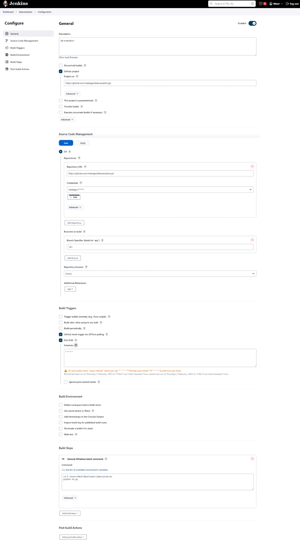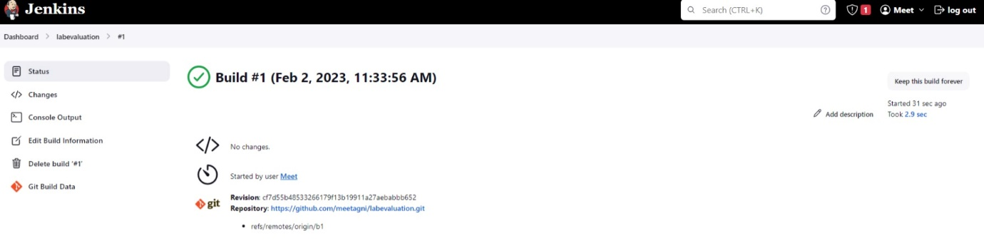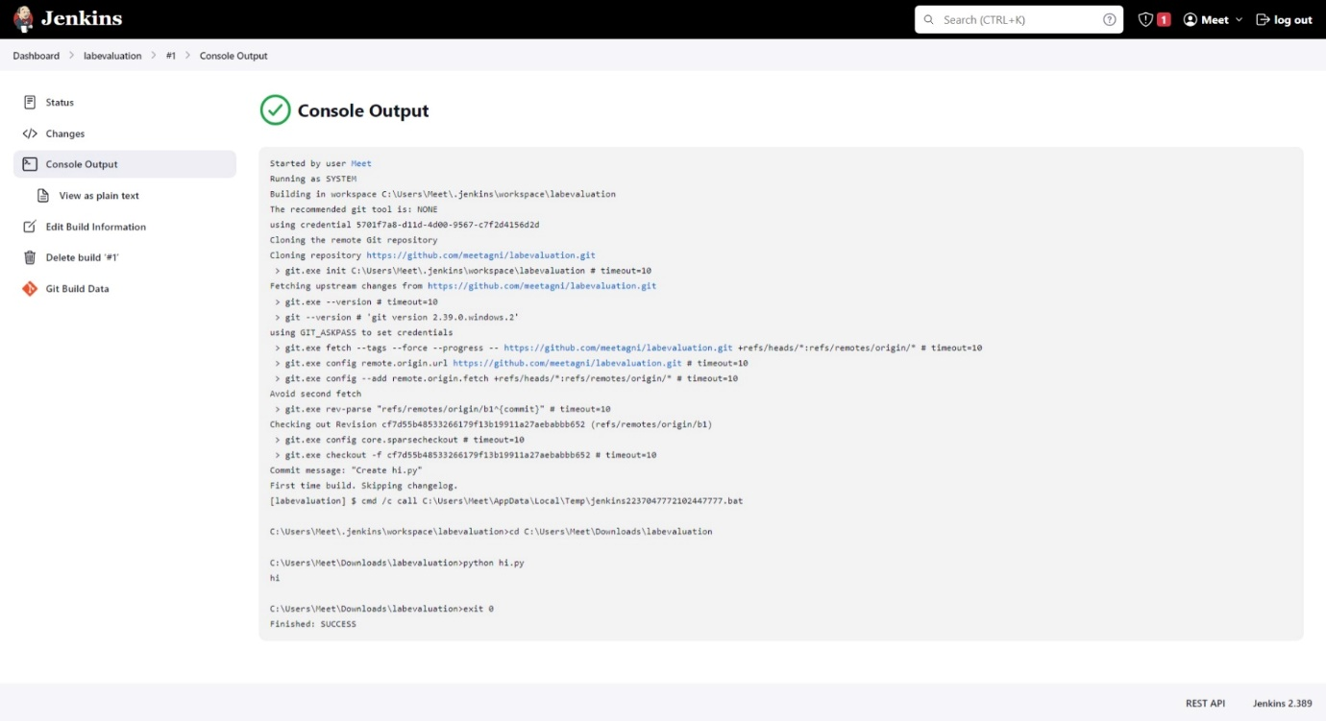

Q3. Diabetes dataset questions:

1.no of patients not readmitted after treatment

2.no of patients readmitted within 30 days

3.no of patients readmitted after 30 days

4.range of ages which is affected by diabetics the most.

5.no.of males or females who are affected by diabetes more

A3.

